
be seen be included be educated
The Pamela Sunter Centre
2 Whitley Street, Bingley,
Bradford, BD16 4JH

Registered Charity No.1130994
A company registered in England and Wales number 6915555

Ltd

Child Protection Policy

Section 1 Introduction
Section 2 Our ethos
Section 3 Implementing the policy
Section 4 DBS clearance and safeguard training
Section 5 Safe recruitment
Section 6 Code of conduct for staff, volunteers and
directors
Section 7 Recognising safeguarding issues
Section 8 Role of safeguarding officers
Section 9 What to do if you are worried about a child
Section 10 Allegations against a member of staff, volunteer
or director
Section 11 Useful contacts

Section 12 Reviewing Policies and Procedures
Appendix A Flow chart of procedure
Appendix B Form for recording safeguarding concerns
Appendix C Online application for DBS check
Appendix D Safeguarding training, e-learning details
Appendix E Form to sign to confirm you have read and
understood our safeguarding policies
Appendix F reference request form covering safeguarding checks

Section 1 Introduction
The Down Syndrome Training & Support Service Ltd (DST&SS) provides support, information, activities, and training for families caring for children with Down syndrome and the professionals who work with them. At the many events arranged to meet this provision the children are accompanied by their parents and/or family members or by a designated one to one carer. The children range from birth to 18+ years of age. On occasions when training is for practitioners/parents only and parents wish to bring along their children, if we are unable to arrange a creche with suitably qualified workers, we always state that their care and supervision is the responsibility of the parents.
These procedures have been designed to ensure the welfare and protection of any child and/or young person who accesses the services provided by Down Syndrome Training & Support Service Ltd. The procedures recognise that child protection can be a very difficult subject for workers to deal with to the extent that it is sometimes easier to close your eyes to what is happening or believe that it is somebody else’s problem to deal with. The Down Syndrome Training & Support Service Ltd is committed to the belief that protecting children and young people is everybody’s responsibility and therefore the aim here is to provide guidelines that will enable all workers and volunteers to act appropriately to any concerns that arise in respect of a child/young person.

Section 2 Our ethos

Down Syndrome Training & Support Service Ltd is fully committed to safeguarding and promoting the welfare of all children and young people.
DST&SS has a duty to be aware that abuse, neglect and radicalisation does occur in our society. It recognises its responsibility to take all reasonable steps to promote safe practice and to protect children from harm, abuse and exploitation, prevent the impairment of children’s health or development and ensure that children are in circumstances consistent with the provision of safe and effective care.
DST&SS takes action to ensure all children have the best outcomes and ensures staff are aware of the systems in place to safeguard children.

Down Syndrome Training & Support Service Ltd acknowledges its duty to act appropriately to any allegations, reports or suspicions of abuse.

Paid staff, volunteers and directors will endeavour to work together to encourage the development of an ethos which embraces difference and diversity and respects the rights of children, young people and adults.

Everyone working in our setting recognises their responsibilities towards the children attending our centre. We understand that safeguarding is not just about protecting children from deliberate harm, but it relates to all aspects of care and education relating to children’s wellbeing, health and safety.

DST&SS ensure all visitors are recorded, monitored and know how to raise safeguarding concerns if needed. Signposts are located around the centre with the Child Protection and Vulnerable Adults Flow Chart. (See appendix A)

Children have the right to be treated with respect and to be safe from any abuse in whatever form.

The DST&SS will work with children, parents, carers, school, external agencies and the community to ensure the welfare and safety of children.

Section 3 Implementing the policy

In implementing this child protection policy Down Syndrome Training & Support Service Ltd will:

- train all staff to understand our safeguarding policy and procedures, and ensure that all staff have up to date knowledge of safeguarding issues.
- ensure that all workers understand their legal and moral responsibility to protect children and young people from harm, abuse and exploitation;

- ensure that all workers understand their duty to report concerns that arise about a child or young person, or a worker’s conduct towards a child/young person, to the safeguarding officer, SO, (also known as the child protection officer)

- aim to provide a safe, respectful and supportive environment for children to allow them to feel confident to approach adults and feel secure in the knowledge that they will be listened to.
- ensure that children and young people are enabled to express their ideas and views on a wide range of issues and give feedback on these issues.
- aim to ensure that adults talk and listen to children where they have concerns about their safety and wellbeing.
- ensure that parents/carers are encouraged to be involved in the work of the organisation and, when requested, have access to all guidelines and procedures;

- create an environment to encourage children to develop a positive self-image and self-esteem.

- encourage children to develop a sense of independence and autonomy in a way that is appropriate to their age and stage of development
- endeavour to keep up-to-date with national developments relating to the welfare and protection of children and young people.

Section 4 DBS clearance and safeguard training

We aim to provide a secure and safe environment for all children. DST&SS will therefore not allow an adult to be left alone with a child who has not received their DBS clearance.
The Down Syndrome Training & Support Service Ltd will ensure that all staff receive copies of policies and procedures relating to the safety and protection of children and sign to say that they understand their responsibilities under these procedures. See Appendix E.

DBS checks will take place at the start of a workers employment, paid or voluntary, and prior to any contact with children. This can be initiated online, see appendix C. All staff will be encouraged to apply for the DBS update service which must be done once the DBS is received.

DBS checks will be renewed every three years for voluntary staff, directors and Speech and Language Therapists. Paid members of staff will be registered with the update service when their DBS check is renewed. All staff now need to transfer to the update service, and this will be done when their current DBS is renewed.

If any issues or queries are raised DST&SS have the right to request a new DBS check at any time on any member of staff, volunteer or director.

All staff, volunteers, Directors and therapists are responsible for notifying the SO in person should any circumstances arise, that may affect their suitability to work with children/young people or carry out their role within the charity. This will include any incidents occurring outside the setting. Staff will face disciplinary action should they fail to notify the manager in a reasonable timescale.
Down syndrome training and Support service abides by the employer’s responsibilities relating to informing the Independent Safeguarding Authority of any changes to the suitability of their staff, whether this member of staff has left the setting or is still under investigation.

Training
The Down Syndrome Training & Support Service Ltd will ensure that all staff members whether paid or unpaid, undertake training to gain a basic awareness of the signs and symptoms of child abuse

At induction all staff/volunteers will receive Basic Level 1 training via the Safeguarding everyone eLearning site. See Appendix D. Refresher training will be every 2 years. Frontline staff will receive level 2 safeguarding training and will take an annual level 2 refresher course. The Safeguarding Officer will receive external level 3 safeguarding training every 2 years and undertake an additional training required.
Annual in-house training, monthly staff meetings and annual appraisals will be used to update the staff team’s knowledge and understanding of safeguarding issues.
The SO will be responsible for any support the staff/volunteer team may have between these reviews. This includes mentor support, one-to-one training sessions, on-going supervision, work-based observations and constructive feedback.
Should staff have to deal with any possible abuse or neglect issues they will receive emotional support from the management team or external agencies if required.

Section 5 Safe recruitment
The Down Syndrome Training & Support Service Ltd is striving to be an equal opportunity employer and abides by the Equality Act 2010. Therefore, we will aim to treat all workers and job applicants equally. There will be no discrimination in respect of marital status, gender, sexuality, disability, age, colour, race, religion or belief (or lack of belief), nationality, ethnic or national origins. There will be no discrimination on these grounds in the terms and conditions offered to workers or job applicants.

DST&SS have a Public Sector Duty to consider all individuals when carrying out their day-to-day work – in shaping policy, delivering services and in relation to their own employees. DST&SS has a responsibility to eliminate discrimination, advance equality or opportunity and foster good relations between different people when carrying our activities.

Preventing unsuitable people from working with children
DST&SS has a duty to ensure that people looking after children are suitable to fulfil the requirements for their role. We will follow Safer Recruitment practices including verifying qualifications and ensuring appropriate DBS and reference checks are undertaken. We will not allow people whose suitability has not been checked, to have unsupervised contact with children. We will:
- Prepare clear job descriptions; person specifications; develop standardised questions for interview purposes.
- All publicity/the application form will clearly state that the position will involve working with children and will require an enhanced DBS Disclosure. A self declaration will also be used for screening applicants prior to the interview stage.
- Check full employment histories which should cover at least the previous 5 years. Any gaps in employment should be explained.
- Check Identities and Qualifications. At least 2 forms of identification provided at interview and certificates relating to qualifications. This could also be supplemented with a check to the awarding body if any doubts exist.

- Obtain references. The referee should be informed the person has applied for a post that involves contact with children/young people. They should be asked to comment on the candidate’s suitability to work with children and an opinion on their suitability within this role. The referee must be informed they may be contacted for further information. See appendix F.

- Inform successful candidates that the appointment will be subject to satisfactory references and a clear enhanced DBS check.

Staff are expected to disclose any convictions, cautions, court orders, reprimands and warnings which may affect their suitability to work with children (whether received before or during their employment at the setting).

DST&SS will abide by the Human Rights Act 1998. DST&SS will let you defend your rights in UK courts and treat you equally with fairness, dignity and respect.

DST&SS will ensure that any disciplinary proceedings against staff relating to child protection matters are concluded in full even when the member of staff is no longer employed at the setting and that notification of any concerns is made to the relevant agencies, the Disclosure and Barring Service (DBS) and included in references where applicable.

DST&SS will ensure that all new employees and volunteers will be checked against the Disclosure and Barring Service (DBS) to eliminate any potential risk. The check includes a police database check. (See appendix C)

Section 6 Code of conduct for staff, volunteers and
Directors

The DST&SS will ensure that the code of conduct for workers training with young people is followed at all times.

The code is designed to minimise situations where abuse may occur by stipulating that:

- Exercise caution about being alone with a child. In situations where this is unavoidable, ensure another worker or volunteer knows what you are doing and where you are. Where appropriate, ensure a door remains open to the room in which you are alone with a child.
- Ensure that any physical contact is open and initiated by the child’s needs, e.g., for a hug when upset or help with toileting. Always prompt children to carry out personal care themselves and if they cannot manage ask if they would like help.
- Where possible encourage parents to take responsibility for their own children
- all activity, as far as possible, is publicly observed or conducted in a group setting;
- inappropriate touching of any form is never permitted; See touch policy.
- the use of inappropriate language never goes unchallenged;
- Be clear with anyone disclosing any matter that could concern the safety and wellbeing of a child that you cannot guarantee to keep this information to yourself
- You should not be under the influence of alcohol or any other substance which may affect your ability to care for children.
- Seek opportunities for training
- appropriate action will be taken in all cases and instances of child protection concerns involving young people;
- a ‘whistleblowing’ policy will be adhered to. This will ensure that staff who make bona fide complaints about colleagues’ behaviour will not be punished, even if the concerns prove unfounded.

In addition to this the DST&SS has a Complaints and Compliments Policy that covers situations of inappropriate conduct by staff and the mechanisms for complaining about this.

Section 7 Recognising safeguarding issues

Definition of Abuse

The Down Syndrome Training & Support Service Ltd recognises that it has a duty to act on reports or suspicions of abuse. It also acknowledges that acting in cases of child abuse is never easy. However, we believe that the safety of the child should override any doubts or hesitations.

Abuse refers to:
27. Physical abuse: a form of abuse which may involve hitting, shaking, throwing, poisoning, burning or scalding, drowning, suffocating or otherwise causing physical harm to a child. Physical harm may also be caused when a parent or carer fabricates the symptoms of, or deliberately induces, illness in a child.
28. Emotional abuse: the persistent emotional maltreatment of a child such as to cause severe and adverse effects on the child’s emotional development. It may involve conveying to a child that they are worthless or unloved, inadequate, or valued only insofar as they meet the needs of another person. It may include not giving the child opportunities to express their views, deliberately silencing them or ‘making fun’ of what 9 they say or how they communicate. It may feature age or developmentally inappropriate expectations being imposed on children. These may include interactions that are beyond a child’s developmental capability as well as overprotection and limitation of exploration and learning or preventing the child from participating in normal social interaction. It may involve seeing or hearing the ill-treatment of another. It may involve serious bullying (including cyberbullying), causing children frequently to feel frightened or in danger, or the exploitation or corruption of children. Some level of emotional abuse is involved in all types of maltreatment of a child, although it may occur alone.
29. Sexual abuse: involves forcing or enticing a child or young person to take part in sexual activities, not necessarily involving violence, whether or not the child is aware of what is happening. The activities may involve physical contact, including assault by penetration (for example rape or oral sex) or non-penetrative acts such as masturbation, kissing, rubbing, and touching outside of clothing. They may also include non-contact activities, such as involving children in looking at, or in the production of, sexual images, watching sexual activities, encouraging children to behave in sexually inappropriate ways, or grooming a child in preparation for abuse. Sexual abuse can take place online, and technology can be used to facilitate offline abuse. Sexual abuse is not solely perpetrated by adult males. Women can also commit acts of sexual abuse, as can other children. The sexual abuse of children by other children is a specific safeguarding issue in education and all staff should be aware of it and of their school or college’s policy and procedures for dealing with it.
30. Neglect: the persistent failure to meet a child’s basic physical and/or psychological needs, likely to result in the serious impairment of the child’s health or development
All adults have the right to be safe from harm and should be able to live free from fear
of abuse, neglect and exploitation. (See Vulnerable Adults Policy)
All staff need to familiarise themselves with these definitions.
All staff are encouraged to report any form of abuse. Staff are not alone and must not keep abuse to themselves.
It is not the responsibility of the staff to investigate welfare concerns or determine the truth of any disclosure or allegation. All staff however have a duty to recognise concerns and maintain an open mind. All concerns regarding the welfare of children must be recorded and discussed with the SO and prior to any discussion with parents/carers. The SO will monitor vulnerable children and any changes or concerns will be reported.
The Down Syndrome Training & Support Service Ltd has an Incident Book where the SO, will record any reported incidents or breach of Child Protection policies and procedures. This will be kept in a secure place and its contents will be confidential.

Section 8 Role of safeguarding officers

Laura Hempel, Wendy Uttley and Jenny Rowlands, DST&SS are the nominated Safeguarding Officers, with Laura Hempel the lead officer. Her responsibility it is to ensure that all necessary measures are in place to safeguard children. In her absence, a deputy will always be available for workers to consult with. The named persons for Child Protection within the Down Syndrome Training & Support Service Ltd are:

Lead contact person: Laura Hempel
Work telephone number: 01274 561308
Mobile number: 07849 347041
Emergency contact no: 07849 347041

Name of contact person: Wendy Uttley
Work telephone number: 01274 561308
Mobile number: 07816 465845

Name of contact person: Jenny Rowlands
Mobile number: 07850 654667
Emergency contact no: 01423 610255 (home)

The Safeguarding Officer should inform the Safeguarding Board of any allegation of serious harm against, or abuse of a child reported by any person looking after them at the centre, (whether that allegation relates to harm or abuse committed at the centre or elsewhere), and the action taken in respect of these allegations need also to be reported and if necessary; any other significant event that is likely to affect the suitability to look after children at our centre.

Notification must be made as soon as is reasonably practicable, but always within 14 days. A safeguarding officer, without reasonable excuse, failing to comply with these requirements is committing an offence.

Responsibilities of the SO
It is the overall responsibility of the SO to ensure that all necessary measures are in place to safeguard children and that all staff adhere to the policy and procedures. The Safeguarding Officer’s responsibilities are as follows: -

- To have completed the required BSCB (Bradford Safeguarding Children’s Board) training in safeguarding and to keep this up to date with all current training.
- To ensure that there is a suitable policy in place which is updated and reviewed annually and with current BSCB guidance.
- To follow and carry out all BSCB procedures.
- To ensure staff are fully trained and equipped to fulfil their role with regards to safeguarding children and that they have a refresher training annually
- To ensure that safer recruitment procedures are followed when recruiting and monitoring ongoing staff suitability.
- To deal with all allegations against staff or persons working within the setting.
- Liaising with other agencies and services where appropriate
- To seek advice and support for staff from relevant agencies where appropriate.
- To talk to parents about concerns (where appropriate)
- Keeping up-to-date records and to ensure they are stored securely.
- To refer a child to Children’s and Families Services if there are any concerns about suspected abuse or neglect by telephone and followed up in writing. (This is to be followed up in writing to services, in our own records or both)
- To attend multi-agency strategy meetings, child protection meetings, contribute to a children in need or child protection plan and attend case conferences when necessary.
Any child protection concerns should only be shared with staff on a ‘need to know’ basis. Consideration should be taken as to which staff this concerns and how much information needs to be shared. This is usually information that staff will require to ensure the safety and welfare of the child.

Section 9 What to do if you are worried about a child

The Down Syndrome Training & Support Service Ltd recognises that it has a duty to act on reports or suspicions of abuse. It also acknowledges that taking action in cases of child abuse is never easy. However, the Down Syndrome Training & Support Service Ltd believes that the safety of the child should override any doubts or hesitations. When worrying changes are observed in a child’s or young person’s behaviour, physical condition or appearance staff will:

Stage 1

- Initially talk to a child/young person about what you are observing. It is okay to ask questions, for example: “I’ve noticed that you don’t appear yourself today, is everything okay? But never use leading questions
- Listen carefully to what the young person has to say and take it seriously;
- Never investigate or take sole responsibility for a situation where a child/young person makes a disclosure;
- Always explain to children and young people that any information they have given will have to be shared with others;
- Record what was said as soon as possible after any disclosure;
- The person who receives the allegation or has the concern should complete the pro-forma and ensure it is signed and dated. See appendix B
- Respect confidentiality and file documents securely;
- Notify and pass on the concern to the organisation’s Named Person for Child Protection –SO.

Stage 2

- The SO will take immediate action if there is a suspicion that a child has been abused or likely to be abused. In this situation the SO will contact the police and/or Children’s Social Care. If a referral is made direct to Children’s Social Care this must be followed up in writing as soon as possible.
- The SO can also seek advice and clarity about a situation that is beginning to raise concern through the NSPCC National Child Protection Helpline on 0800 8800 5000

A flowchart outlining these stages is included, see appendix A

Section 10 Allegations against a member of staff, volunteer
or director

It is the duty of all staff to report to the SO anyone working at the setting who is:
- Not following setting policies and procedures.
- Displaying inappropriate conduct e.g., inappropriate sexual comments and behaviours, sharing or discussing sexual photos or images
- Giving excessive 1:1 attention beyond the requirements of their usual role and responsibility
- Taking and/or sharing child abuse images
- Any concerns of radicalisation shown in a change of behaviour
The Down Syndrome Training & Support Service Ltd will ensure that any allegations made against members, or a member of staff will be dealt with swiftly and in accordance with these procedures:
- The worker must ensure that the child is safe and away from the person whom the allegation is made
- The SO should be informed immediately. In the case of an allegation involving the SO, alternative arrangements should be sought to ensure that the matter is dealt with by an independent person. (Note: this could be a director or anyone within the organisation that is in a senior position and believed to be independent of the allegations being made)
- The SO should contact the local area children’s department for advice on how to proceed with the immediate situation. Outside of working hours the Emergency Duty Team can give advice and/or in the event of an emergency situation arising, the police
- The individual who first received/witnessed the concern should make a full written record of what was seen, heard and/or told as soon as possible after observing the incident/receiving the report. It is important that the report is an accurate description. The named person (if appropriate) can support the worker during this process but must not complete the report for the worker. This report must be made available on request from either the police and/or social services
- Regardless of whether a police and/or social services investigation follows, Down Syndrome Training & Support Service Ltd will ensure that an internal investigation takes place and consideration is given to the operation of disciplinary procedures. This may involve an immediate suspension and/or ultimate dismissal dependent on the nature of the incident.
- The member of staff will remain employed on full pay and benefits but on ‘Garden Leave’ until a full investigation has been carried out, and a decision has been made as to whether the complaint or allegation was justified or not. If the member of staff is not deemed to pose a risk to children, staff or parents/carers then they will remain on the premises and continue to work whilst the complaint/allegation is investigated.
- Staff must not make any comments either publicly or in private about a parent’s or staff’s supposed or actual behaviour.

Section 11 Useful contacts
Useful Contacts/Support Organisations
- During office hours (8.30 - 5.00 Monday to Thursday, 4.30 on Friday) call Children's Services Contact Centre - 01274 435600 to refer any child in need, including child protection concerns.
- At all other times, Social Services Emergency Duty Team - 01274 431010
- If you have reason to believe that a child is at immediate risk of harm, contact the police on 999
- Specific advice about issues concerning South Asian children can be sought on the NSPCC National Child Protection Asian Helpline on 0800 096 7719.
NSPCC Child Protection Helpline

The NSPCC Child Protection Helpline is a free 24-hour service that provides counselling, information and advice to anyone concerned about a child at risk of abuse. Telephone: 080 8800 5000 - Email: help@nspcc.org.uk

Other areas Social Services:
- Leeds Referral hotline 0113 376 0336 or outside office hours 0113 5350600 Children’s Emergency Duty Team

Wakefield Child Protection Unit, Social Care Direct 03458503503
- Kirklees Gateway to care 01484 414933 (outside office hours)
- Calderdale Initial Response Team 01422 393336

Section 12 – Reviewing Policies and Procedures

This policy is to be reviewed annually in November of each year.

Any changes/amendments will be clarified and shared with staff and where significant changes appear they will be relayed to parents/carers.

Relevant Legislation

Human Rights Act 1998

Equality Act 2010

Public Sector Duty

Counter Terrorism and Security Act 2015

Related Policies

Vulnerable Adults Policy

Touch Policy

E-Safety and social media Policy

Recruitment Policy and Procedures

Disciplinary Rules & Procedures Policy

Dated…………………………….Signed…………….…………………….

Updated: February 2024

Next Update: February 2025

Review Period: 1 year

Appendix A Flow chart of procedure

Child Protection & Vulnerable Adult Procedures Flow Chart

On discovery or suspicion of child abuse
If in doubt – ACT

Inform your Named Person for Child Protection

Laura Hempel Wendy Uttley Jenny Rowlands
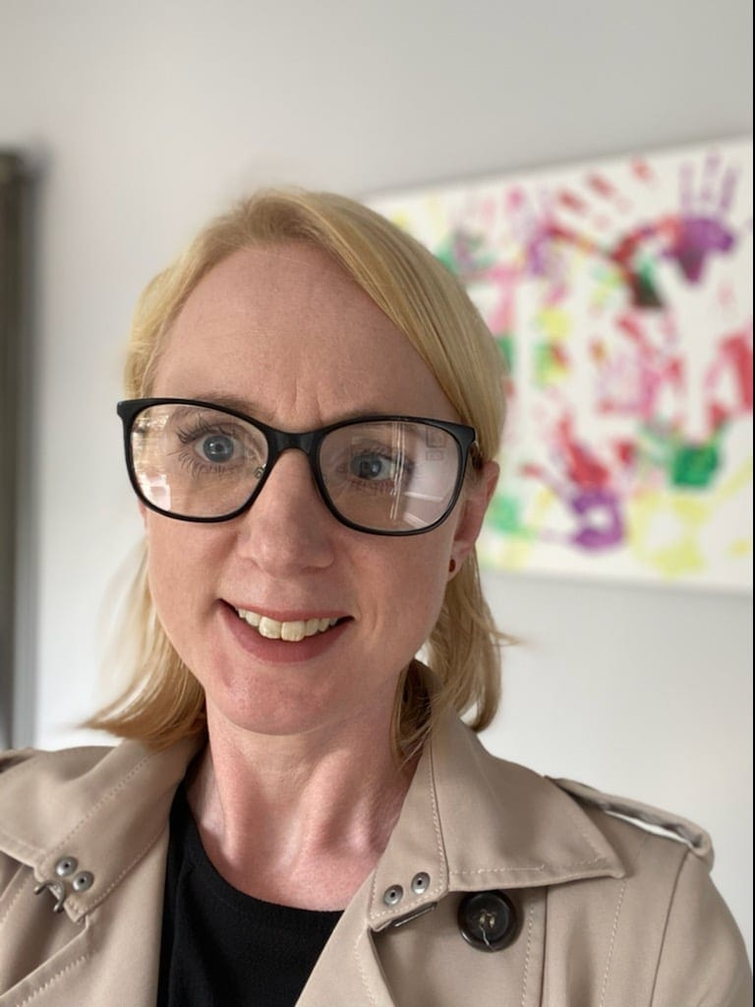
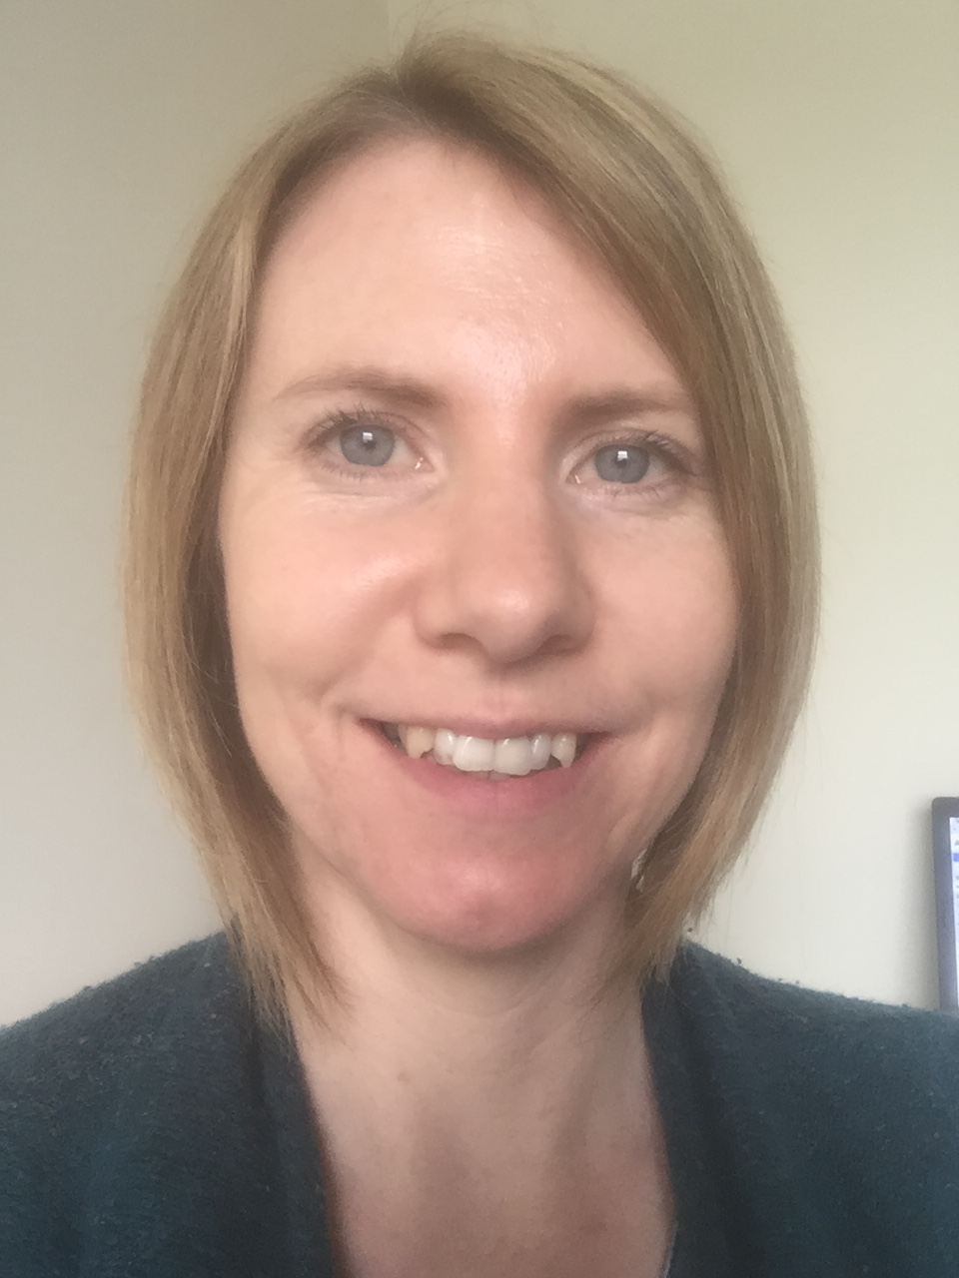
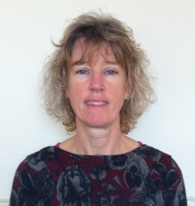

07426 540271 07816 465845 07850 654667

Who should then take the following steps
One of the named persons will take a written record of concerns from you (or you can write your own record and pass it to them) This will be kept confidential in a locked file.

Where it is clear that a Child Protection Referral is needed, they will contact Children’s Initial Contact Point without delay Tel No 01274 435600
Children with complex needs Tel No 01274 435751
Out of hrs Emergency Duty Team Tel No 01274 431010
Named Persons may also seek advice from the Children’s Specialist Services
Tel 01274 435600
IF THERE IS AN IMMEDIATE RISK OF HARM CALL 999

If you are asked to monitor the situation, make sure you are clear what you are expected to monitor, for how long and how and to whom you should feedback information to.

Remember always make and keep a written record of all events and action taken, date and sign each entry to this record. Keep records confidential and secure.
Ensure immediate completion and dispatch of the Common Child Protection Referral form.
Send copies to:
- Children’s Social Care
- Principal Education Social Worker Future House, Bolling Road, Bradford BD4 7EB

USEFUL TELEPHONE NUMBERS
Children’s Social Care Initial Contact Point: 01274 435600
Emergency Duty Team: 01274 431010
Childrens Specialist Service: 01274 435600Police: Bradford Safeguarding Unit: 01274 431077
Appendix B Form for recording safeguarding concerns

Recording is a valuable tool in child protection; any concerns for the welfare of a child or young person should be recorded on the recording pro-forma.

The purpose for these recordings are to accurately register and pass on information to other professionals in order that informed decisions can be made and that should patterns emerge they do not go unnoticed. Every worker who has cause for concern / suspicion of harm or who directly takes a disclosure must make a recording. Recordings will also be made by the manager of any action taken.

CONFIDENTIAL

This pro-forma must be completed by any worker who receives an allegation/disclosure of abuse from a child/young person or who has concerns about a child/young person. Fill in the information given to you or write down your concerns. Do not try to ascertain further details, or ask investigating questions. If you do not know then leave the section blank.

Details of the young person:

Name………………………………………… Date of Birth……………….

Address…………………………………………………………………………………

Who has parental responsibility: ………………………………………………….

Address…………………………………………………………………………………

Name & address of other significant adults:

Name | Relationship | Address | Date of Birth

Details of siblings:

Name | Address | Date of Birth/or age

What professionals are you aware of that are currently in contact with the child/young person e.g., teacher, youth worker, social worker, health visitor, doctor etc?
Name | Agency | Address | Contact Number

Please record the details of what information was given/shared with you by the child/young person, you must use their words. Alternatively, please record in detail your concerns about the child/young person
Please read the above and ensure that it contains fact and not workers opinion.

State date & time of the above.

Date……/……. /……….. Time…………… Venue………………………………………………

APPENDIX C online application for DBS check

We require all our staff and volunteers to have a DBS check (formerly called CRB). If you already have one from another place of work we can accept that if it is under three years old and covers both child and vulnerable adults. If not, you will need to complete an application online.

Go to www.dbsassist.co.uk/ucheck

- Click on DBS Application Form – “start application”

- Enter organisation reference – DOWN6 (capital letters)

- Enter password – downsix (lower case)

- Click Enter

The first page to appear will be the Statement of Fair Processing which you need to tick at the bottom of the page to confirm

- The blank application will then appear
Complete the application using the notes on the right hand side of the screen for guidance

Please don’t use the term “Volunteer”. Your job is “support worker CA” working with “Child and vulnerable adults”. This enables us to clear you to be used as a volunteer in any of our activities. If you don’t want to be cleared to work with vulnerable adults, it may restrict how we can use you, but it is by no means obligatory.

- Click on the box to indicate consent

- Click on complete

- Click home

Then you’re finished. Let us know via phone (01274 561308) or email (office@downsyndromebradford.co.uk) and we will complete the verification process using the details we have taken from your ID. If we haven’t seen your ID, we will need to see and photocopy two of the following documents 1) your passport, 2) driving licence and / or 3) birth certificate. we will also need to see a recent, less than three months old, bank statement / council tax bill / for confirmation of your address

Should you have any problems with the online DBS application feel free to call and we can arrange for you to come to the office for support in completing the form.

Appendix D Safeguarding training, e-learning details

In the absence of any proof of previous Safeguarding Training, all staff, Directors and volunteers are required to complete a Bradford Safeguarding Children Board (BSCB) online course. Volunteers and back room staff are required to complete “An Introduction to Safeguarding Children”. They will need to retake this online course every three years as a refresher. Frontline staff will be expected to complete the online course “Level 2 Safeguarding Children”. Then an annual refresher course: “level 2 Safeguarding Children Refresher Training”.
You will be reminded when your update is due to be taken.
In order to complete the required Safeguarding Training, you need first to register online. You will be asked to complete a registration form and will then be emailed by Virtual College with you login details.

- Got to www.saferbradford.co.uk
- Scroll down to ‘learning and resources’ and click
- Click on ‘Training’ tab
- Click on e-learning course
- Click on ‘for information – booking on a course’
- Click on New user ‘self-registration page’
- Fill in your details
Job title ‘volunteer’
Area of Work ‘charity’
Work address ‘Down syndrome training and support services’
Managers name ‘Wendy Uttley’
Manager email ‘office@downsyndromebradford.co.uk
Group ‘Voluntary/not for profit sector’
- Click ‘REGISTER’
- Then it will email you a username (your email address) and a password
- Go to your email ‘inbox’ and wait for an email from ‘VIRTUAL COLLEGE’. This will include your password and a link to book onto a course.
- Scroll down to the correct course ‘Level 1 Safeguarding everyone’ or ‘level 2 safeguarding children’ and click ‘ENROL’ (You should be told which course to take. If unsure call Heidi in the office)
- Click ‘NEXT’ then in the text box type ‘I am required to take this training to be able to volunteer at Down Syndrome Training and Support Service Ltd’
- Click ‘ENROL’
- You will receive a message on the homepage (red flag, top of page) with the link to start the training.

You can continue with the course there and then should you so wish or go back to it at a later date. The course must be completed within 6 weeks of registering. The course doesn’t need to be completed in one sitting and progress can be saved.

Once you have completed the course and taken the short quiz, please print the certificate and forward it to us as proof of training completion.

You are very welcome to come to the office and complete the course here should you require support or assistance.

Appendix E Form to sign to confirm you have read and
understood our safeguarding policies

NAME...........................................................

CONFIRMATION OF READING AND UNDERSTANDING RESPONSIBILITIES UNDER OUR SAFEGUARDING PROCEDURES

I have read the vulnerable adults policy and understand my responsibilities and what action I need to take under these procedures

Signed………………………………………………………. date……………………………

I have read the child protection policy and understand my responsibilities and what action I need to take under these procedures

Signed………………………………………………………. date……………………………

I have read the touch policy and understand my responsibilities and what action I need to take under these procedures (youth club only)

Signed………………………………………………………. date……………………………

I have read the Social Media and E-Safety Policy and understand my responsibilities and what action I need to take under these procedures

Signed………………………………………………………. date……………………………

I have a completed the Introduction to Safeguarding online training

Signed……………………………………. date……………………………

APPENDIX F

Reference Request Form
Name of Applicant:
Post Applied for:

What is the name of your organisation:
What position do you hold in relation to the applicant:
How long have you worked/did you work with the Applicant:
Please confirm the Applicant’s role and/or duties:
Please confirm the Applicant’s dates of employment: Employment commenced: Employment ended:
Please confirm the reason for the termination of the Applicant’s employment (If the Applicant was dismissed, please explain the reason for the Applicant’s dismissal and the surrounding circumstances.):

Please rate the Applicant against the following criteria: (please continue on separate sheet if required)
Please rate the Applicant against the following criteria: (please continue on separate sheet if required) | Needs substantial develop-ment | Needs develop-ment | Acceptable | Strong | Outstanding
Attitude to work
Reliability
Working relationships with other staff
Skills
Experience

Has the Applicant been the subject of disciplinary proceedings (whether formal or informal) during the last 12 months of their employment? If so, please provide details of the allegation (s) against the Applicant and the outcome of the proceedings. Yes / No *delete as appropriate
Has the Applicant been the subject of disciplinary proceedings (whether formal or informal) involving issues related to the safety and welfare of children or young people? If so, please provide details of the allegation (s) against the Applicant and the outcome of the proceedings. Yes / No *delete as appropriate

Please provide details of any allegations or concerns that have been raised (whether formally or informally) about the Applicant which relate to the safety and welfare of children or young people:

With reference to the attached job description, are you satisfied that the Applicant has the ability and is suitable to undertake this role? If not, please give specific reasons for your concerns. Yes / No *delete as appropriate

Are you completely satisfied that the Applicant is suitable to work with children? If, not please give specific reasons for your concerns. Yes / No (*delete as appropriate)

Would you be willing to re-employ the Applicant? If your answer is “No”, please explain why. Yes / No (*delete as appropriate)

Please include any other information which you consider may be relevant to the Applicant’s application:

If the applicant requests to see a copy of this reference, please indicate if you are happy for this reference to be shared with the applicant: YES / NO* (Delete as appropriate)
If you are NOT happy for the applicant to see this reference, please state your reasons:

(Depending on the circumstances, we may still be legally required to share this reference with the candidate.)
Signed:
Please print name:
Job Title: Dated:
Telephone No: Extension:
E-mail address:
Organisation’s name and address:

APPENDIX G



